***CSS:***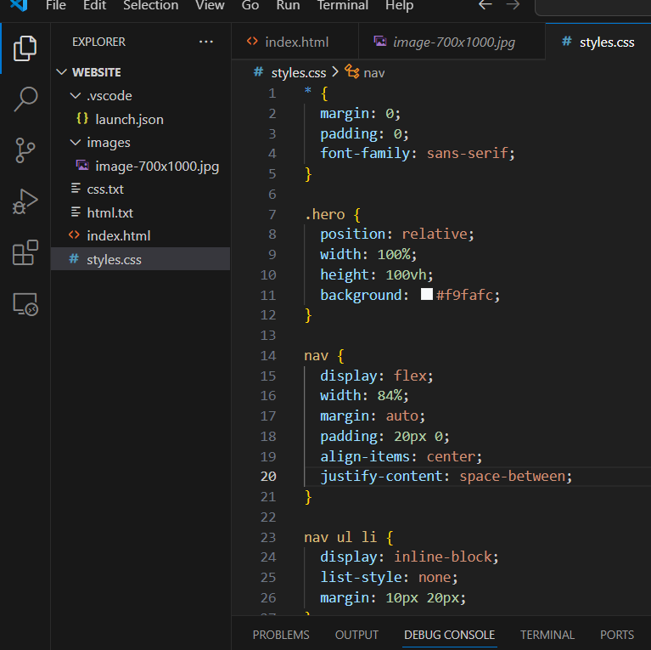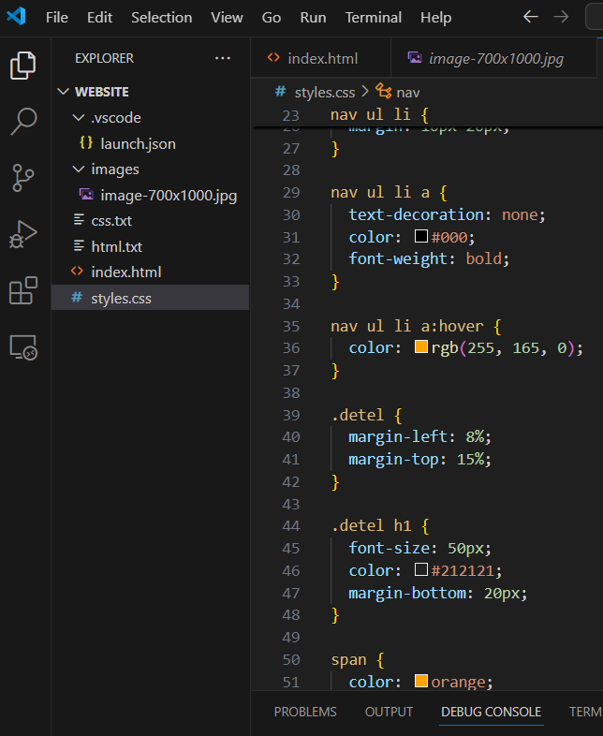

***HTML:***

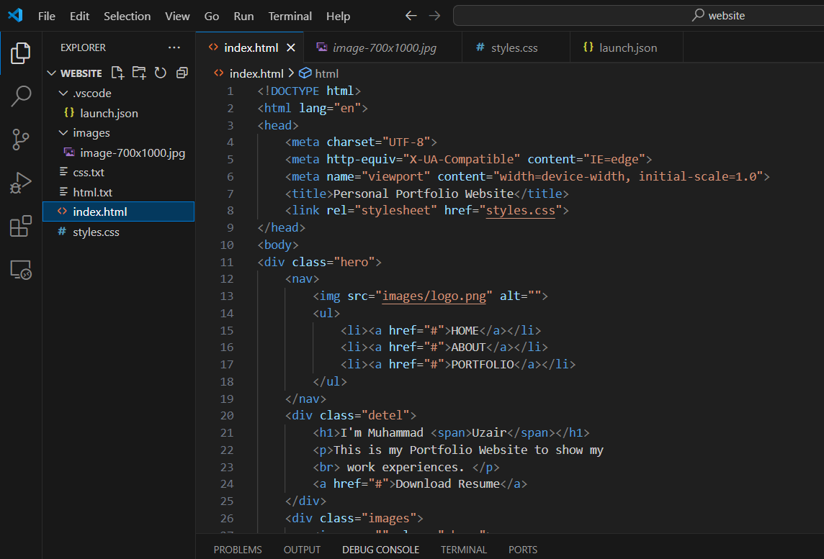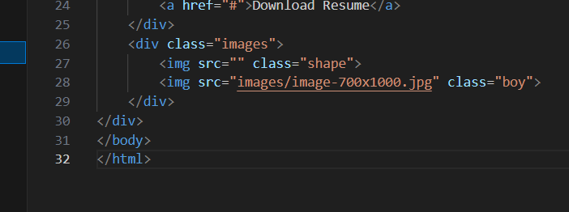

***OUTPUT:***

